BUDAPEST BUSINESS SCHOOL
- Useful & Practical Information Brochure -

WELCOME TO BUDAPEST BUSINESS SCHOOL!

There are a few things what good to know:

1. Academic Calendar 2020/2021 2
Fall Semester 2
Spring Semester (Subject of change. We will update it in October!) 3
2. Faculty of Finance and Accountancy (FFA) 4
3. Electronic systems: NEPTUN, COOSPACE, MODULO, access to WIFI-SYSTEM 5
Information on NEPTUN System - Registering for subjects and exams, making payments via Neptun 5
Information on CooSpace 5
Modulo 5
WIFI 6
4. Costs of living in Budapest 6
5. Public transport 7
6. Shopping 10
7. Currency 10
8. Communication 10
9. Culture 12

Academic Calendar 2020/2021

Fall Semester
REGISTRATION PERIOD
Registration period | 31 August – 6 September, 2020
Arrival days (for exchange students only) | 3 – 6 September, 2020
Orientation days (compulsory)  – Neptun Day and Freshmen’s Day –  (for exchange students only) | 3 September, 2020

STUDY PERIOD (15 weeks)
First day of tuition | 7 September, 2020
Autumn break | 19 – 24 October, 2020
National holidays | 1 November, 2020
First mid-term assignment period | 26 – 31 October, 2020
Second mid-term assignment period | 7 – 12 December, 2020
Last day of tuition | 14 December, 2020

EXAMINATION PERIOD (6 weeks)
First day of examination | 14 December, 2020
Last day of examination | 23 January, 2020

Spring Semester (Subject of change. We will update it in October!)
REGISTRATION PERIOD
Registration period | 1 – 5 February, 2021
Arrival days (for exchange students only) | 3 – 5 February, 2021
Orientation days (compulsory)  – Neptun Day and Freshmen’s Day –  (for exchange students only) | 4 February, 2020

STUDY PERIOD (15 weeks)
First day of tuition | 8 February, 2021
Spring break | 16 – 19 March, 2021
National holidays | 15 March, 6 April, 24 May
First mid-term assignment period | 22 – 26 March, 2021
Second mid-term assignment period | 10 – 14 May, 2021
Last day of tuition | 16 May, 2021

EXAMINATION PERIOD (6 weeks)
First day of examination | 17 May, 2021
Last day of examination | 28 June, 2021
Summer holiday | from the end of semester 2 (Spring) until the beginning of semester 1 (Autumn)

Faculty of Finance and Accountancy (FFA)

The building is in the 14th district a few kilometres from the centre of Budapest. The address is 1149 Budapest, Buzogány street 10-12.
It is easily accessible by public transport as follows:
- by Metro-line 2 (M2) → Ferenc Puskás metro station
  - 80A trolleybus
  - 130 bus until Kaffka Margit bus stop.
- from Keleti railway station → 80A trolleybus until Kaffka Margit bus stop.

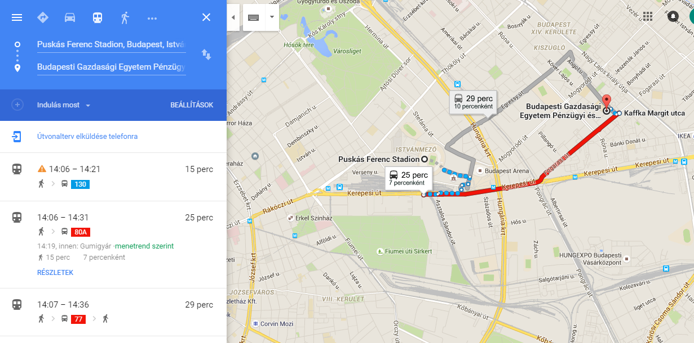

In case you have any questions, do not hesitate to contact our International Coordinators: Ms. Éva Gál and Ms. Erzsébet Schrauf-Csizmadia,
e-mail: gal.eva@uni-bge.hu; schrauf-csizmadia.erzsebet@uni-bge.hu
telephone: 00 36 1 469-6600 / extension: 6520

Electronic systems: NEPTUN, COOSPACE, MODULO, access to WIFI-SYSTEM


Information on NEPTUN System - Registering for subjects and exams, making payments via Neptun

Students can manage study matters online, through the Neptun system (e.g. registering for the semester, registering for subjects and exams); they can trace their performance (electronic- grade book), money matters (e.g. scholarships, student credit), but any other matters, too, can be taken care of with a few clicks, instead of standing in long lines (e.g. applying for a student card or a place in a hall of residence, application for the modification of a tuition fee).


Information on CooSpace

CooSpace is an online learning environment, which has useful functions for students. It makes communication among students and professors easy and fast. The latter is a fast internal messaging service. The personal document storage space makes it possible to store and organize all the source materials of your courses and subjects well organized into folders.
The system can be started by clicking on the CooSpace icon. Your access codes are the same as those you use for all the other digital platforms of the school.
When you have entered the site, on the main page you can see those sections which have been created by the teachers/professors. It is recommended that you use your own calendar on the right-hand side of the main page so that you can keep track of deadlines.



Modulo

Students may submit applications regarding several matters. The applications – according to the Education and Examination Regulation (TVSZ, HTJSZ etc.) – are assessed by the competent committees or persons: the Study Committee, the Credit Transfer Committee, the Dean or the Assistant Dean for Education. Applications must be submitted using the Modulo system. (However, if you encounter problems with the system, your applications will be accepted in paper form).
Modulo is a web based system to support dealing with official matters. Students can easily, without standing in a queue, deal with their official matters by filling in electronic application forms. (Certain rules, of course, must be complied with – e.g. the deadlines of submission should be kept, the required documents should be attached, etc.)

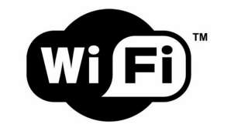

WIFI

You can use WIFI at each Faculty of the BBS. There is internet connection in the Dormitories as well. You can easily access the “eduroam” network by using the login: your Neptun Code@uni-bge.hu and your password.

Costs of living in Budapest

You will need at least 80,000 Hungarian forints (approx. 270 Euros) per month to cover the costs of accommodation including utilities, pay for local transport, and even go out occasionally. This amount should cover the costs of utilities, shopping for everyday items and local transport. The final amount will depend on whether you rent a room, a flat, or whether you are accommodated in a dormitory. There are regional differences in this amount: life in Budapest is more expensive than in other Hungarian cities.
Living costs (food, transport, miscellaneous): about EUR 250 – 400 per month.

Average prices:
- rent of a small flat in Budapest (per month): from 70.000 HUF (220 EUR) + utilities (200-230 EUR), depending on the size and location of the flat
- rent of a room in Budapest (per month): from 60.000 HUF (190 EUR) + utilities
- 1 loaf of bread: 270 HUF (1 EUR; 1.5 USD)
- 1 bottle of beer: 250 HUF (1 EUR; 1.4 USD)
- 1 bottle of wine: from 1.000 HUF (3.5 EUR; 3.5 USD)
- 1 liter of milk: 220 HUF (1 EUR; 1.4 USD)
- eating out: 1.500-2.500 HUF (5-8 EUR; 6-12 USD)
- daily menu: 890-1.500 HUF
- cinema ticket: 1.090-1.670HUF (4 EUR; 5.5 USD); Digital 3D 1.600-2.100HUF
- academic related expenses (books, photocopying, etc.): about EUR 50 – 100 per semester.

Public transport

Budapest has an efficient network of public transport, including bus, trolley bus, tram, metro services plus suburban railway lines called HÉV lines and boat services. Tickets are available at metro stations or street kiosks. Passengers can use the same type of ticket for all forms of public transport (except boat services) but they need to validate a new ticket when making transfers. Bus drivers on specific routes do sell tickets but passengers need to prepare exact amounts as no change will be given back. If one regularly uses public transport, it is economically more viable to buy a monthly pass.
Please note that you will get a Student Card which will enable you to get student discount of monthly Budapest pass.

One single ticket is valid for one uninterrupted journey of up to 60 minutes, whereas a pass is good for unlimited travel in Budapest.
Tickets and passes can be purchased at major Metro stations, such as Deák Tér.
Tickets can be validated by means of meters on board of buses and trams or at entrances of metro stations. The validated tickets should be kept till the end of the trip and handed over to the controller on request. It is cheaper to buy a 10-piece discount coupon book ("gyűjtőjegy": 3.000, - HUF) than buying the single tickets separately.

Important: You must have a ticket or a valid pass before boarding the vehicles. The tickets should be validated by the punchers before starting your trip on the Metro lines, or right after embarking other means of transport. BKK officials are authorized to check the validity of your ticket or pass any time during or after your trip. Passengers without valid ticket or pass are to pay a heavy fine - 16.000,- HUF (approx. 55 euros) on the spot. If it happens to you that you leave at home your monthly ticket, you have to present your pass and cash or bankcard payment at the Surcharge Office (Budapest, 8th district, Akácfa u. 22) strictly within 2 working days

In case you are in possession of a pass and a related ID (student ID, personal photo ID) that was valid at the time of control having been purchased before but was not presented, you can take care of penalty fare payment within 2 workdays from the issuance of the penalty fare at 1072 Budapest Akácfa u. 22 by presenting the pass or travel document and paying the appropriate fee. The fee is 2,000 then. This option is available up to twice in each calendar year.
The option of presenting their pass is available to the customer only if you have no current debt due to a previous violation.
A pass purchased after the issuance of a penalty fare is not accepted for presentation.

If your friends or relatives may visit you, they can choose from the following options while traveling on Budapest public transport:
• a single ticket
• a Budapest 24-hour travel card
• a 7-day travel card
• a 14-day pass
• a monthly Budapest pass. The monthly pass allows you to travel
day and night on any vehicles run by BKV (Budapest Transport Limited).




Buses, trolley buses, tram
Budapest has more than 200 bus routes covering most inner city and suburban areas. Some routes offer an express service, indicated with an E following the bus number. Express and regular services cover the same routes but express services have a reduced number of stops. On the main routes, service are available even during the night hours.
Night buses are operating during night too in Budapest.


Metro
Budapest metro has four lines, three of which (M1, M2 and M3) intersect at Deák tér:
M1: the Yellow Line between Vörösmarty tér and Mexikói út.
M2: the Red Line between Déli pályaudvar and Örs vezér tere,
M3: the Blue Line between Újpest Központ and Kőbánya-Kispest,
M4: the Green Line between Kelenföld vasútállomás and Keleti pályaudvar.
Each metro station is marked with a letter M enclosed in a circle. Although navigating in the Budapest metro poses no difficulty for tourists, metro maps are available at any of the station entries. Metro services run from 4:30 until 23:30.



HÉV
The suburban train service of Budapest called HÉV connects Budapest with its suburban areas.
HÉV lines are also numbered: H5, H6, H7, H8 and H9. A popular journey for tourists is from
Batthyány tér to Szentendre by the line H5. If you leave the administrative border of Budapest, you need to purchase an additional ticket to your destination.

Taxi
When taking a taxi, tourists should avoid hailing unmarked taxi cabs. Even if they have a taxi sign on the roof and are seen standing at taxi ranks, do not get in the car unless they have a company name on the outside of the car. You can always hail a taxi in the streets but it is cheaper to book one over the phone. From September 2013 every taxi in Budapest is uniformly yellow and the fares are fixed.

Shopping

Food shops are open Monday–Sunday.
Most stores are open from Monday till Friday between 10:00–18:00 or 20:00 and on Saturday and Sunday between 10:00–17:00. Shopping centres have longer opening hours, from Monday till Sunday between 10.00–19.00. Stores of the following chains can be found in most cities in Hungary: Tesco, Spar, Lidl, Aldi, CBA.

Currency

Forint (HUF) has been the local currency in Hungary.
Banknotes come in denominations of 500, 1000, 2000, 5000, 10,000 and 20,000.
Six different coins are in use: 5, 10, 20, 50, 100 and 200 forint coins. (It is important to be aware when you pay cash, the bill will be rounded up or down so that the last digit will always be five or zero.) Credit cards are accepted at many places.

Communication

Phones
Hungary’s country code is 36. To make a long distance call within Hungary, you have to dial 06 followed by the area code, then the actual number. ‘Green numbers’ starting with 06 80 are free of charge.
If you plan to live in Hungary for a while, look out for discounts by using phone cards. In Hungary there are three service providers: Telekom, Telenor and Vodafone, whose networks can be accessed all over the country. They all offer prepaid cards, which you can buy at newsstands, post offices and petrol stations.
Hungarian mobile number
In Hungary there are three mobile service providers: Telekom, Telenor and Vodafone. Since you are a foreign student, you can only buy pre-paid mobile number which means that every time you do not have enough money on the card you have to go either to the mobile service provider, the news agent’s or bank automat to top up your phone credit.
For buying a pre-paid card you need to have the following documents with you:
ID card / passport containing your visa
You can find the shops of the mobile service providers almost everywhere, but the best option is if you go to a shopping mall, for example Árkád (Budapest, Örs vezér tere 25/A, 1106) or Westend (Budapest, Váci út 3, 1062).

Postal services
There are numerous post offices throughout the country. Opening hours vary, depending on office locations. Mail boxes are red and bear the word: ‘Posta’. Besides mailing your letters at a post office, this is also a place where you can pay your bills, transfer money, send faxes, buy phone cards.

Culture

If you want to enjoy Hungarian culture, rich cultural life awaits for you in every town, especially in the capital.

Cinema
Besides Hollywood movies, Hungary offers a wide selection of art films from all over the world. You can choose from various films, dubbed or subtitled, depending on your knowledge of foreign languages.

Theatre
There is a very rich and active theatre life throughout the country. The season starts in September and ends in May. To be on the safe side, you should book your tickets well in advance for the play of your choice. There are several performances in English language.

Museums and Art Galleries
The best places to learn about Hungarian culture, art and history are exhibitions. Museums are open from 10 am to 6 pm, and are usually closed on Mondays. If you use your student ID, you will be entitled to a discount from the ticket price.

